**RENTAL CONNECT: AN EFFECTIVE LANDLORD TO TENANT AND**

**TENANT-TO-TENANT WEB-BASED COMMUNICATION SYSTEM**

MOTURI, GLORIA MORAA

100090

An Information Systems Project Proposal submitted to the Strathmore Institute of Management and Technology in partial fulfilment of the requirements for the award of the Diploma in Business Information Technology of Strathmore University

Strathmore Institute of Management and Technology

Strathmore University

Nairobi, Kenya

07-JUNE-19

# Declaration

I declare that this work has not been previously submitted and approved for the award of a Diploma by this or any other University. To the best of my knowledge and belief, the proposal contains no material previously published or written by another person except where due reference is made in the proposal itself.

Student: Gloria Moraa Moturi

Sign: …………………………………… Date: …………………………………………

# Approval

The Information System Project proposal of ***GLORIA MORAA MOTURI*** was reviewed and approved (*for examination*) by:

Supervisor: Humphrey Owour

Sign: …………………………………… Date: …………………………………………

# Acknowledgement

The writing of this project proposal has required a lot of guidance and assistance from many people. I would like to express my gratitude to my supervisor, Mr. Humphrey Owour, for the useful comments, remarks and guidance he provided. In addition, I would like to thank my lecturer, Mr. Tiberius Tabulu, for providing the proper foundation to start this proposal and develop it. I heartily thank all the landlords and tenants who participated in the research of this proposal. I am also thankful for the constant support and encouragement I got from my family members. Finally, I thank God for giving me the strength and opportunity to complete this proposal.

# Abstract

For most Kenyans, building rental properties has become an increasingly popular way to invest their money and thus they have taken on the role of a landlord. The landlord runs the day-to-day operations of managing and maintaining rental properties. The property management market, unlike other sectors, has not yet fully embraced technological advancements that would solve most of the problems in the industry. Several advancements have been made such as the creation of platforms that automate standard procedures such as generating invoices. However, the issue of ineffective communication between landlords and tenants and between tenants and tenants is yet to be addressed. There have been cases of misinterpretation of information, late responses and lack of records of communication among others. This has led to a lack of accountability and has negatively affected the rental business.

The main aim of this project was to develop a web-based system that provides a simple, effective and efficient channel of communication between landlords and tenants and among tenants. The methodology that was used to develop the system was a combination of design thinking and agile methodology as they are interactive and incremental.

The system allows tenants to submit maintenance requests and track them. In addition, it allows them to interact with other tenants through direct chats and an online notice board. The landlord is able to easily send rent and deposit reminders and any other information. It enables ease of access to rental information, shorten the response time, increase accountability and thus improve relations.

**Table of Contents**

Declaration i

Approval i

Acknowledgement ii

Abstract iii

List of Figures v

List of Abbreviations vii

Chapter 1: Introduction 1

1.1 Background 1

1.2 Problem Statement 2

1.3 General Objective 3

1.4 Research Objectives 3

1.5 Research Questions 3

1.6 Justification 3

1.7 Scope 4

1.8 Limitations and Delimitations 4

Chapter 2: Literature Review 5

2.1 Introduction 5

2.2 Communication Problems Faced by Landlords and Tenants 5

2.3 Existing Methods of Communication 6

2.3.1 Face-to-Face Meetings 6

2.3.2 Mail 6

2.3.3 Telephonic Communication 6

2.3.4 Texting 6

2.3.5 Email 7

2.3.6 Social Media 7

2.4 Existing Rental Communication Systems 7

2.4.1 PropertyVista 7

2.4.2 Tellus 8

2.4.3HeyLandlord 10

2.5 Gaps in Existing Systems 12

2.6 Conceptual Framework 13

Chapter 3: Research Methodology 15

3.1 Introduction 15

3.2 System Development Methodology 15

3.2.1 Design Thinking 15

3.2.2 Agile Methodology 16

3.3 Functional and Non-functional Requirements 18

3.3.1 Functional Requirements 18

3.3.2 Non-Functional Requirements 19

3.4 Tools and Techniques 19

3.5 Deliverables 20

References 22

Appendix 23

# List of Figures

Figure 2. 1 PropertyVista Application 8

Figure 2. 2 Tellus Chats 9

Figure 2. 3 Tellus Ticket for Repairs 10

Figure 2. 4 HeyLandlord Application 11

Figure 2. 5 HeyLandlord Features 11

Figure 2. 6 Conceptual Framework 14

Figure 3. 1 Design Thinking Steps 15

Figure 3. 2 Agile Methodology 17

# List of Abbreviations

CSS – Cascaded Style Sheets

HTML – Hypertext Mark-up Language

PHP – Hypertext Preprocessor

DBMS – Database Management System

DFD – Data Flow Diagram

# Chapter 1: Introduction

## 1.1 Background

According to the National Housing Corporation, Kenya has an annual housing deficit of 300,000 units. To ease the problem, 150,000 new units are needed per year. The urge to seal the housing gap and reap huge profits while at it, has attracted more investors to the sector. Kenyans are rushing to set up rental properties as they offer a proven way to build equity and earn sure income (Guide to Becoming a Successful Landlord, 2017).

A rental property is a property from which the owner, landlord or lessor, receives payment from the occupant(s), known as tenants or lessees, in return for occupying or using the property. Rental properties may be either residential or commercial (Rental Property, 2019).

There are many actors involved in the supply of housing such as landlords, tenants and service providers. The renting process begins with an individual identifying a property he or she would like to rent. The landlord then screens the potential tenant by running a background check to see whether they will be able to pay the rent. Afterwards, the landlord and tenant sign a rental agreement, or lease ,that will include details such as the amount of rent, penalties for late payments, length of the lease and other rental details.

The primary responsibility of the landlord is to ensure safety of their property and to keep it well maintained. It is also their responsibility to make sure that their tenants are aware of their duties and responsibilities, and to help address any issues they may have before and during their tenancy. It is a tenant’s duty to keep the property clean and safe, and promptly report any faults and defects that arise with the property (The Tenants Voice, 2019).

To avoid unnecessary inconveniences resulting from tenancy disputes, it is important that the tenant have a full understanding of his or her rights and the tenancy agreement he or she is signing. A huge number of complaints filed at the Business Premise Rent Tribunal by tenants reporting harassment by landlords reveal the reality of the unevenness in the relationship between the landlord and a tenant in Kenya. Unjustifiable rent increment, verbal abuse, threats, utilities cut off and improper waste disposal are just but a few of the problems city tenants are faced with in the hands of rogue landlords. (Onyango, 2018).

The property management market has incorporated technology in some of its operations. This has managed to solve some of the problems in the industry. Several advancements have been made such as creation of platforms that connect landlords to potential tenants. For example, BuyRentKenya, an online property site which is committed to improving property purchasing or renting in Kenya. In addition, there are platforms that automate standard procedures such as generating invoices and receipts online and sending them via email, and notifying landlords on overdue rent and upcoming payments.

Despite these advancements, effective landlord to tenant and tenant-to-tenant communication is still a challenge. There are problems such as limited or close to none tenant involvement in property management, unresponsiveness, late responses, lack of flow of information, misinterpretation of information, language barriers, lack of material evidence of communication and a lack of a direct channel of communication between tenants.

## 1.2 Problem Statement

Effective landlord to tenant and tenant-to-tenant communication is key for successful property management. It results in smooth running of the property and leads to satisfied tenants. Unfortunately, the communication process used is extremely inefficient. It has been plagued with problems such as late responses, lack of records of communication and misinterpretation of information. In addition, most tenants lack a direct way to communicate with each other and often resort to using the landlord as an intermediary. Lastly, the biggest challenge has been juggling of information from different communication channels such as texts, emails and letters.

Both stakeholders require valuable and timely information, which is impaired by inefficient communication. This has led to delays, confusion, disputes and a decrease in tenant satisfaction.

There is a need for a simple, effective and efficient communication system that will enable a tenant to communicate with the landlord and other tenants. It has features such as direct chats and a maintenance request module where tenants are able to submit and track their maintenance requests. This has benefits such as increased response time and easy access to maintenance records thus improving accountability. Furthermore, the system has an online notice board where tenants and landlords are able to post information they would like to share with everyone. This improves communication between landlords and tenants as well as among tenants, and ultimately leads to better property management and social cohesion.

## 1.3 General Objective

The aim of this project was to develop an efficient and simple web-based landlord-tenant communication system that will enable effective communication between landlords and tenants and among tenants.

## 1.4 Research Objectives

1. To discuss the communication challenges faced by landlords and tenants.
2. To analyze existing channels of communication used by landlords and tenants to communicate with each other.
3. To analyze and design a simple and effective landlord to tenant and tenant-to-tenant communication system.
4. To develop and test the system.

## 1.5 Research Questions

1. What communication challenges do landlords and tenants face?
2. What channels of communication are currently being used by landlords and tenants to communicate with one another?
3. How can a simple and effective landlord to tenant and tenant-to-tenant communication system be analyzed and designed?
4. How can the system be developed and tested?

## 1.6 Justification

Landlords and tenants need a communication system that will connect all the stakeholders by providing one central online location for communicating. The proposed system will enable effective communication between the two groups, as it will be easily accessible, secure, user friendly and meet the users’ needs such as submission of maintenance requests and tracking.

This will ensure long-term tenancies and lower vacancy rates for landlords by achieving a good customer satisfaction. Most importantly, it will improve relations hence establishing a community within the property.

## 1.7 Scope

The scope of the project was to create a web-based system that will allow easy, effective and efficient landlord to tenant and tenant-to-tenant communication in Kenya. It covers both residential and commercial rental properties.

## 1.8 Limitations and Delimitations

The system will not be able to reach a multilingual customer base, as it is available in one language, English.

# Chapter 2: Literature Review

## 2.1 Introduction

The purpose of this chapter is to discuss communication problems faced by landlords and tenants, existing communication channels used and their shortcomings. It will also include existing systems that have attempted to solve the problem and their associated problems and gaps. Lastly, includes a conceptual framework that explains how the system will effectively solves the communication problem.

## 2.2 Communication Problems Faced by Landlords and Tenants

There are numerous communication problems faced by landlords and tenants. The problems discussed shall cover both landlord to tenant communication and tenant-to-tenant communication.

Some landlords rarely get in touch with their tenants and this has led to some of them feeling unappreciated. Frequent communication can boost relations between landlords and tenants and thus lead to happy tenants. However, some landlords may manage multiple properties and have a large number of tenants. Communicating individually with each of them may prove to be repetitive and time wasting. For example, notifying tenants on upcoming rent payments and important changes. Some landlords have adopted communicating through one tenant. However, not including all the tenants has led to some tenants feeling left out.

Some landlords have chosen channels of communication that take long to deliver the message or deliver it to the wrong address, for example through postal. Other methods of communication do not leave a record of communication and this has made later referral impossible. Another communication problem is unclear information. For example, a tenant may submit a maintenance request but not include all the details that would help the landlord determine the problem and solve it. This would lead to the landlord having to inquire more about the problem or having to physically visit the property, which would waste time.

Some tenants may not know each other as their paths may not have crossed due to busy schedules. This makes communication among tenants impossible. This leaves the landlord to act as a link between tenants. This does not enable effective communication as it wastes time, information may be altered and does not promote interaction between tenants. For example, if a tenant has a complaint about another tenant, he or she will have to communicate through the landlord due to lack of a proper and easier way to communicate with the other tenant.

All these communication problems have had a negative impact on the rental business and the community in general. They have led to increased tenant dissatisfaction and increased vacancy rates. It has also created disunity among tenants.

## 2.3 Existing Methods of Communication

### 2.3.1 Face-to-Face Meetings

Face-to-face meetings have their various advantages and disadvantages. Some of the advantages include immediate responses and that they help people express their feelings and ideas much better. Most importantly, they create a personal touch. However, it has its limitations such as it is difficult to organize meetings since property office hours usually coincide with regular business hours and tenants having busy schedules. It also does not enable one to keep a record of the conversation.

### 2.3.2 Mail

Sending letters through the postal office is a method of communication that has existed for a long time. The main advantage is that it allows communication with tenants that do not have access to the internet. However, it comes with many disadvantages. Traditional mail is costly compared to other methods, takes time to reach the recipient, may be damaged or lost during transit and may end up being delivered to the wrong address. There is also no way to tell when the letter was sent or when it will be delivered.

### 2.3.3 Telephonic Communication

For most properties, the primary method of communication is by phone. It enables immediate feedback and discussion. The problem is that these days many tenants do not answer their personal cell phones during working hours or late hours. Another disadvantage is that call charges may be hefty if the calls last long durations, if the tenants use different service providers or if it is an international call.

### 2.3.4 Texting

Text messages are received quickly, rarely lost and have a lower probability of going unread. However, it limits the amount of information that can be communicated and texts can be easily lost if the devices used are damaged or lost.

### 2.3.5 Email

Emails are cheaper, delivered extremely fast compared to traditional post, and can be sent at anytime and anywhere. The correspondence can be saved by both parties should a legal dispute arise later on. It keeps a record of messages, replies and details of when the message was received. The main advantage of email is that it allows attachment of electronic files such as lease agreements and photos. However, there are some drawbacks. Majority of people receive many emails and important messages can be easily overlooked. Some emails may also be accidentally sent to the spam folder or spread viruses through attachments. In addition, emails are harder to manage for people managing multiple properties.

### 2.3.6 Social Media

Social media has enabled users to create and share content or to participate in social networking. It is no surprise that some landlords and tenants have used some social media sites such as Facebook and WhatsApp to communicate with each. For example, WhatsApp is a mobile application that has enabled tenants and landlords to send messages to each other, make audio and video calls, and share media such as images. It has also enabled tenants to make WhatsApp groups where they can get to know each other and discuss issues. However, it still has its drawbacks. For example, there is no way to verify the user since it is not password protected, hence anyone can read your messages if they have access to your phone. It also does not provide for an organized system due to the large number of texts one may receive from a group chat.

## 2.4 Existing Rental Communication Systems

### 2.4.1 PropertyVista

PropertyVista is a property management application that has a communications module that enables landlords to easily maintain contact with residents. All you have to do is select the recipients choose a time and method of communication and construct your message. The communication module handles the rest, pushing those messages out with incredible speed and accuracy(Property Vista, 2018).

However, PropertyVista enables landlords to communicate with tenants but does not allow tenants to communicate with each other. In addition, some users have complained about lack of user friendliness. For example, the messages section is confusing as there are too many options depending on where it has come from.

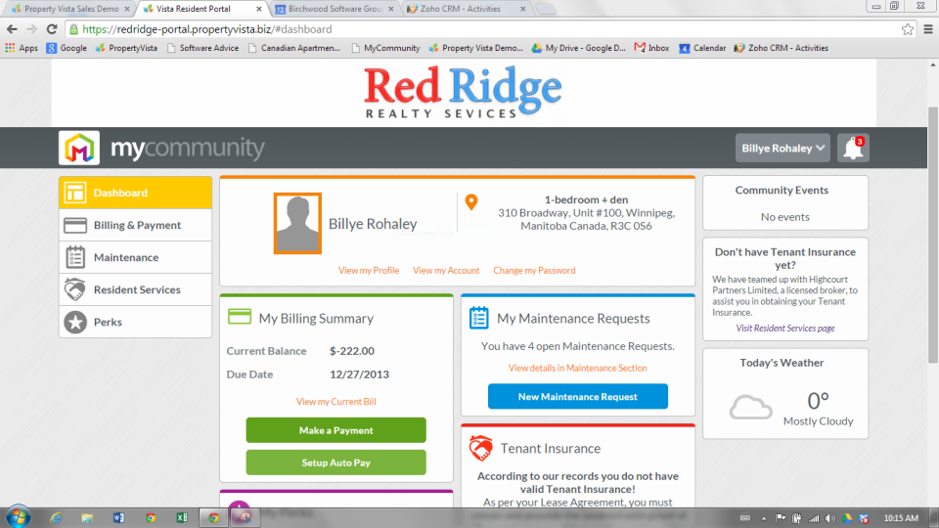

Figure 2. 1 PropertyVista Application (Property Vista, 2018)

### 2.4.2 Tellus

Tellus is a communication application that simplifies the communication process with an intuitive chat platform. Different chats can be created for the appropriate groups, for example, a manager or landlord who wants to chat with tenants in a unit, roommates who want to chat among themselves, an owner and manager who need to discuss logistics with each other or co-managers or co-owners who want a separate management chat. Not only is chat a comprehensive archive, it is also a searchable database so that you can find what you are looking for with ease. Furthermore, all communication through Tellus is backed up to the Cloud. This way, everyone has a record of all decisions and notices and all parties are held accountable. In addition, tenants create tickets for any needed repairs. Landlords upon seeing them will have the option to create a work order. Tenants will see the created work order and know when to expect someone to come fix the problem (Tellus, 2019).

Tellus has been able to simplify the communication process but it still has its drawbacks. For example, Tellus requires the users to download the application on their device. This may prove inconvenient if the device does not have sufficient memory or if the user uses multiple devices.

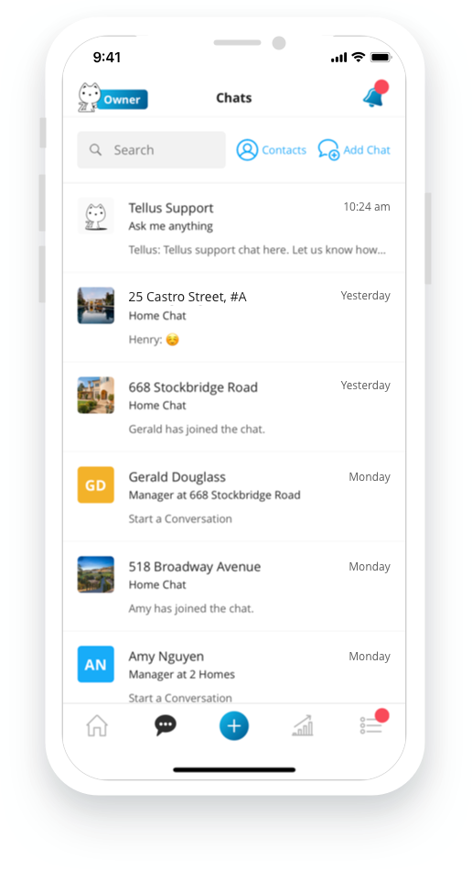

Figure 2. 2 Tellus Chats (Tellus, 2019)

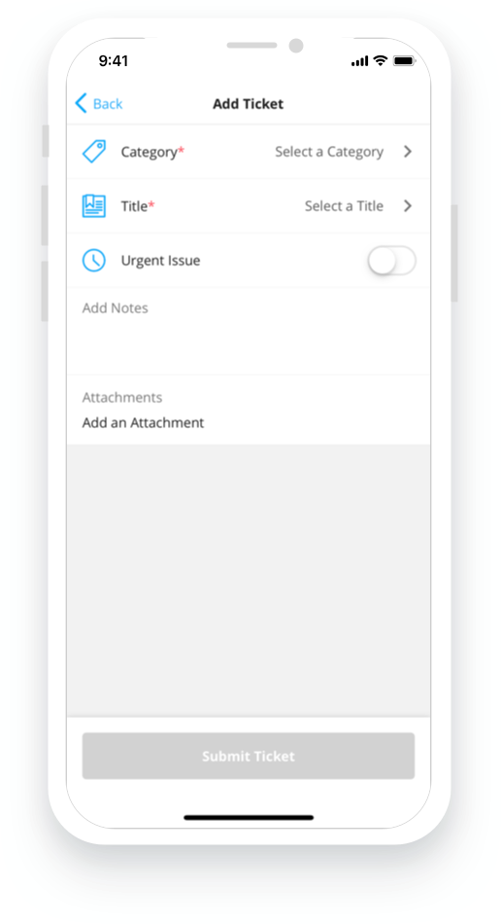

Figure 2. 3 Tellus Ticket for Repairs (Tellus, 2019)

### ****2.4.3HeyLandlord****

HeyLandlord is a property management communication platform that simplifies communication between landlords and tenants. It provides direct chats between landlords and tenants hence eliminating stress of managing emails, text messages, web documents and phone calls. It also eases submitting maintenance requests as tenants can highlight issues by sending photos or videos of the problems that require fixing. The application also broadcasts mobile alerts to tenants for maintenance visits, rent and deposit reminders, emergencies and more. It also enables portfolio management as all property and tenancy details are stored in one space, synchronized across multiple devices, and provides cloud storage. In addition, it establishes a community within building spaces (Hey Landlord Limited, 2019).

However, it does not allow tenants to have chats with other tenants.

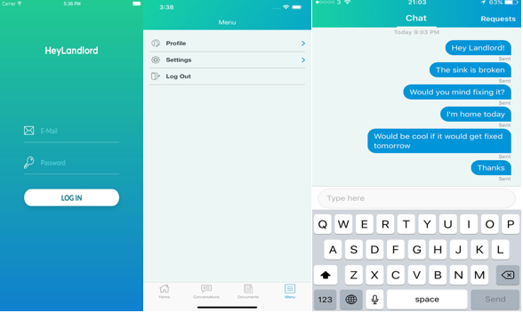

Figure 2. 4 HeyLandlord Application (Hey Landlord Limited, 2019)

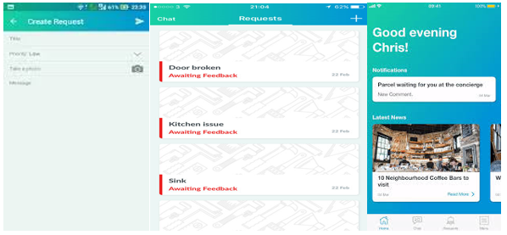

Figure 2. 5 HeyLandlord Features (Hey Landlord Limited, 2019)

## 2.5 Gaps in Existing Systems

Existing systems allow for communication between landlord and tenant but neglect tenant-to-tenant communication. This leaves the landlord to act as an intermediary between tenants. This could lead to misinterpretation of information. In addition, it takes more time for a tenant to communicate through a landlord than if a tenant was to directly communicate with another tenant. This could be quite detrimental if the information is time sensitive. Most importantly, it limits chances of interaction between tenants that could lead to tenants not knowing their neighbors or knowing close to nothing about them. This limits social cohesion.

Existing systems do not enable tenant collaboration in dealing with maintenance requests. In some systems, tenants can only view maintenance requests they have submitted. This limits the chances that tenants could help each other with simple tasks. Enabling tenant collaboration in dealing with maintenance requests would save landlords money by seeing if neighbors can help one another with basic tasks, before deploying expensive contractors. This benefits both business and social cohesion.

A good system should allow you to work, not just from anywhere, but also across multiple devices. Unfortunately, some of these systems require tenants to download apps to their devices. This may prove inconvenient for the users. If a system is web-based, all you need to do is key in your credentials using a web browser and you can operate it from anywhere using any device, as long as you have internet connection(Kendall & Kendall, 2011).

## 2.6 Conceptual Framework

The conceptual framework is a network of interlinked concepts that together provide a comprehensive understanding of the proposed landlord to tenant and tenant-to-tenant communication system.

The system is a web-based system that enables tenants to communicate with landlords and other tenants effectively and efficiently. It allows a tenant or a landlord to create an account based on their role, log in and log out. The account has details of the user that can be easily updated. For example, a tenant account can have the name of the tenant, apartment or house that they occupy, and email address. The account is password protected for user authentication hence achieving security.

Depending on the type of account, the user has certain privileges. Tenants are able to have direct chats with the landlord and other tenants. This makes it possible for them to ask their landlords any questions or clarify information in a less formal setting. It makes it easier for the tenant to approach the landlord and hence improve landlord-tenant relations. Tenants and landlords also have an online noticeboard where they are free to leave any type of messages and notifications, for example, to advertise services, products or events or provide any information they would like to share with other tenants. They are also be able to submit maintenance requests and track them. Tenants are able to view all the maintenance requests to avoid multiple submissions of the same request and be able to help other tenants with simple tasks.

Landlords are able to have direct chats with tenants to communicate information such as upcoming payments, late rent and other details. The landlord is also able to update information on maintenance requests and be able to arrange maintenance visits with tenants. In addition, he or she is able to control the information being posted on the online noticeboard by deleting inappropriate posts.

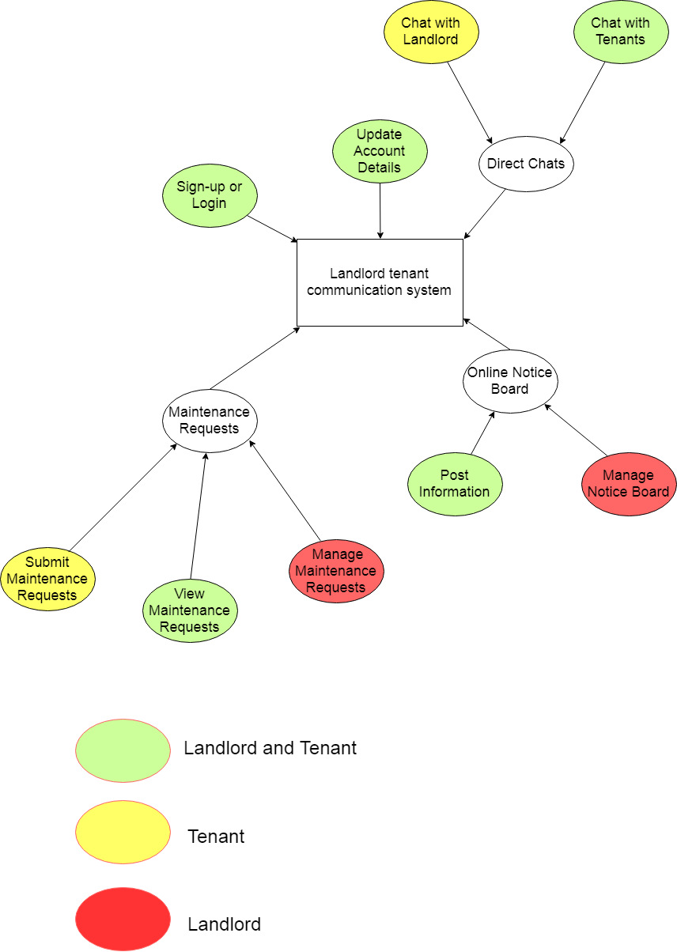

Figure 2. 6 Conceptual Framework

# Chapter 3: Research Methodology

## 3.1 Introduction

This chapter discusses the system development methodology and its justification, functional and non-functional requirements of the system, and tools and techniques that will be applied. In addition, it includes milestones and deliverables of the project, and a project Gantt chart.

## 3.2 System Development Methodology

The system was developed using a combination of two methodologies, design thinking and agile methodology.

Design thinking was chosen to analyze and design the system as it helps people better identify, understand, and address the problems that they are trying to solve while agile methodology has been chosen to implement the system, as it is interactive and incremental.

The combination of these two methods facilitated all the steps necessary to analyze, design, implement, and maintain the communication system.

### 3.2.1 Design Thinking

The design thinking method has five steps. The process starts with empathizing with the problem of the end-user. The process then moves to ideate on solutions. The prototype is developed and then testing is carried out.

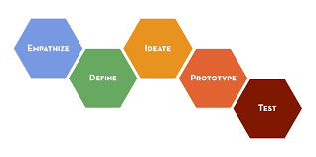

Figure 3. 1 Design Thinking Steps (Tutorials Point, 2016)

1. Empathize

This step involves putting oneself in the shoes of the landlord and the tenants. It is carried out in the form of requirement gathering, which involves interviews and sometimes, even field visits. There was an evaluation of the relationship between landlords and tenants and between tenants and tenants, and the problems that they encounter while communicating with each other.

1. Define

This stage involves defining the problem and arriving at a problem statement. This was achieved using information obtained from the empathize stage. Based on information gathered, this project aimed to solve ineffective communication among tenants and between landlords and tenants.

1. Ideate

The third stage of the design process is ideating which is supposed to bring to the table as many ideas as possible. After defining the problem, one can come up with different ideas that can solve the problem. For example, the proposed system is a web-based system that provides different modules such as a maintenance module and a chat module to solve problems encountered by landlords and tenants while communicating with each other.

1. Prototyping

For this project, the prototyping stage was replaced by the agile methodology, as prototyping may prove difficult to manage.

1. Testing

This is the phase where the final solution was tested on a full-scale basis. A series of tests was run with sample data to pinpoint problems. The functional and non-functional requirements of the system were also tested in this stage. This ensured quality, efficiency and functionality

(Tutorials Point, 2016).

### 3.2.2 Agile Methodology

The agile approach is described as interactive and incremental. There are five distinct stages: exploration, planning, iterations to the first release, productionizing, and maintenance.

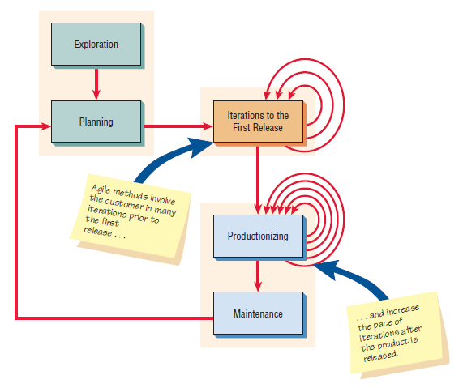

Figure 3. 2 Agile Methodology (Kendall & Kendall, 2011)

1. Exploration

During exploration, you explore the area of study, for this project it is rental communication, and assert your conviction that the problem can and should be approached with agile development. Landlord to tenant communication and tenant to communication was explored in depth.

1. Planning

There are two main players in the planning phase: the developer and the users, landlords and tenants. The purpose of the planning phase was to identify objectives of the communication system and to identify information requirements arising from those objectives.

1. Iterations to the first release

The third stage is iterations that compose of cycles of testing, feedback and change. A series of tests was done using sample data to check for errors. The agile approach advocates tests to check the coding, functionality, performance, and conformance. The system was tested for functional requirements such as does it allow a user to create an account and non-functional requirements such as user friendliness. Incremental changes created through repeated testing and feedback eventually lead to a stable but evolving system.

1. Productionizing

In this phase, the feedback cycle speds up and the product was released, but may be improved by adding other features.

1. Maintenance

Once the system has been released, it needs to be kept running smoothly through maintenance (Kendall & Kendall, 2011).

## 3.3 Functional and Non-functional Requirements

### 3.3.1 Functional Requirements

Functional requirements describe what the system should do so that the user can accomplish a specific task. A functional requirement relates directly to a process the system has to perform as a part of supporting a user task and/or information it needs to provide as the user is performing a task.

The landlord-tenant information system has the following functional requirements:

1. It allows users to create accounts, log in and log out
2. It allow stenants to submit and view maintenance requests.
3. It allows landlords to view and manage maintenance requests.
4. It allows tenants and landlords to have direct chats with each other.
5. It provides a module that enables tenants and landlords to post information they would like to share.

### 3.3.2 Non-Functional Requirements

They describe the quality attributes, design and implementation constraints and external interfaces that the system must have.

1. Availability

The system is available for use 24 hours per day, 365 days per year.

1. Security

This describes who has authorized access to the system and under what circumstances. The system allows for account creation, creating a new account with a password for a user, user verification and privilege granting. For example, a tenant is be able to submit and view maintenance requests but only the landlord is able to update the status of a maintenance request.

1. Usability

The system has a user-friendly interface. It provides quick access to common features such as maintenance requests and is well organized to make it easy to locate different options.

1. Performance

The response time of the system is fast.

1. Reliability

The system has a strategy for error detection and correction. For example, in the case of an invalid input, the system will identify the error and inform the user.

## 3.4 Tools and Techniques

1. Text editor

The landlord-tenant system used Visual Studio Code to edit code.

1. Database management system

A DBMS such as MySQL is used to manage the database. It stores information such as maintenance requests and account details.

1. Web development languages

Web development languages such as HTML, CSS, JavaScript and PHP were used. HTML was used to define the content of the web pages while CSS was used to specify the layout of the web pages. Lastly, JavaScript was used to program the behavior of the web pages while PHP was used as a server scripting language.

1. Virtual server

A virtual server such as XAMPP was used.

1. Diagram software

Draw.io and Lucidchart was be used to make accurate and representative design diagrams.

## 3.5 Deliverables

The deliverables of the project were:

1. Concept note

The concept note was a brief outline of the proposal. It included a background of rental communication and gave a brief explanation of the problem of ineffective communication between landlords and tenants. In addition, it outlined the web based communication system as a solution and an introduction to the methodology that will be used.

1. Project proposal

The project proposal included an introduction chapter, a chapter that dealt with literature review and a chapter covering the methodology.

1. Analysis and design diagrams.

There was inclusion of analysis and design diagrams such as use case diagrams, entity relationship diagrams, database schemas and data flow diagrams.

1. Working web based landlord to tenant and tenant-to-tenant communication system.

It has working modules such as a tenant module and a landlord module. The tenant is able to submit maintenance requests, track them, post on the online notice board and chat with the landlord and other tenants.

The landlord module allows the landlord to manage maintenance requests, manage the online notice board and chat with tenants.

1. Final documentation

The final project documentation enabled the project to run smoother and will make enhancements of the system easier.

# Chapter 4: System Analysis and Design

This chapter includes analysis and design of the system using diagrams. Under analysis, there was use of a use case diagram, sequence diagram, data flow diagrams and entity relationship diagrams. Design was carried out using a database schema and user interface designs.

## 4.1 Use Case Diagram

A use case diagram shows the systems behavior together with the key actors for a specific scenario (King'ori, 2018).

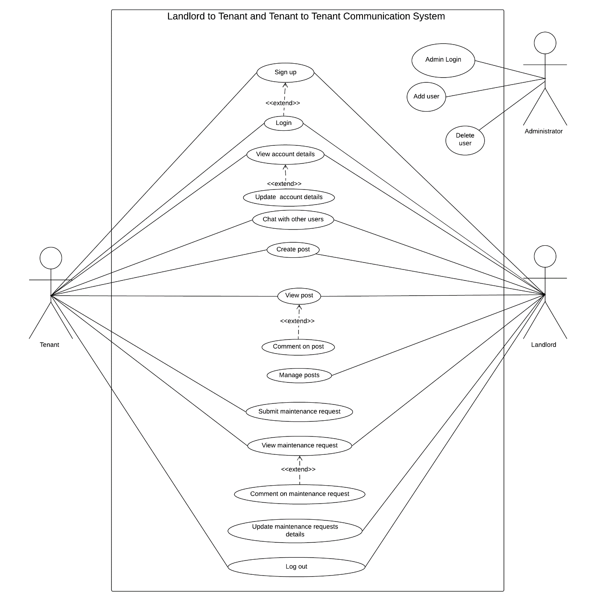

Figure 4.1 shows the use case diagram for the landlord-to-landlord and tenant to tenant communication system. There are three actors, the administrator, the landlord and the tenant. The administrator can login and manage accounts by adding or deleting users. The tenant and landlord can perform a number of similar functions. Both of them can create a new user account by signing up, they can also login into their account, view their account details, and update them. In addition, they can create, view and comment on posts on the online noticeboard. They can also view and comment on maintenance requests. However, only the tenant can submit a maintenance request and only the landlord can manage the posts for example by deleting inappropriate posts or manage maintenance requests by updating details such as dates for maintenance visits and completion dates.

## 4.2 Sequence Diagram

Sequence diagrams show the sequence of activities between objects. Sequence diagrams are derived from use case analysis and are used to derive interactions, relationships and methods of the objects in the system (Kendall & Kendall, 2011).

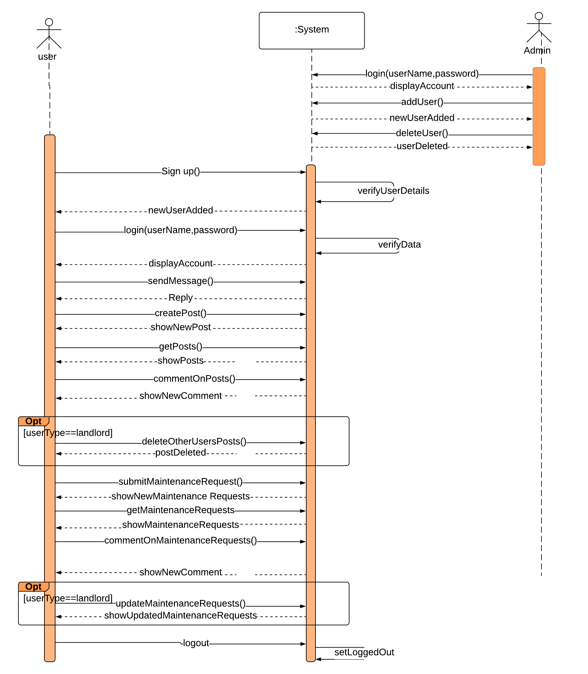

## 4.3 Data Flow Diagrams

A data flow diagram is a graphical tool that shows business processes and the data that flows between them (Dennis, Wixon, & Roth, 2012).

### 4.3.1 Context Diagram

The context diagram defines how the business process or computer system interacts with its environment, primarily the external entities. The context diagram shows the overall business process as just one process and shows the data flows to and from external entities (Dennis, Wixon, & Roth, 2012).

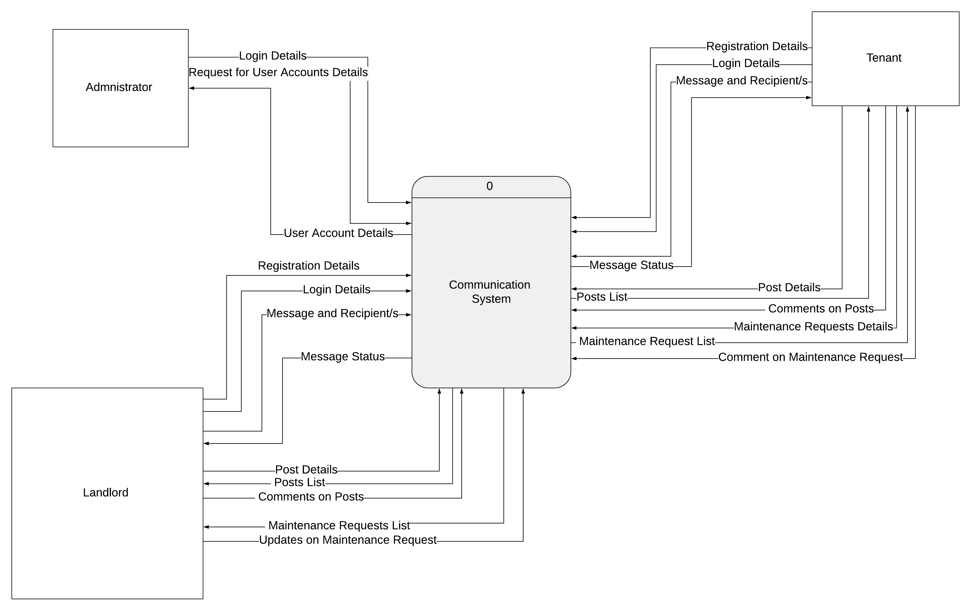

The process symbol in the center represents the system being modeled. There are various external entities such as the administrator, landlord and tenant. All the data flows go to or come from the external entities. For example, registration details come from the landlord and go to the system.

### 4.3.2 Level 0 Diagram

The next DFD is called the level 0 diagram or level 0 DFD. The level 0 diagram shows all the processes at the first level of numbering, processes numbered 1 through 3, the data stores, external entities, and data flows among them (Dennis, Wixon, & Roth, 2012).

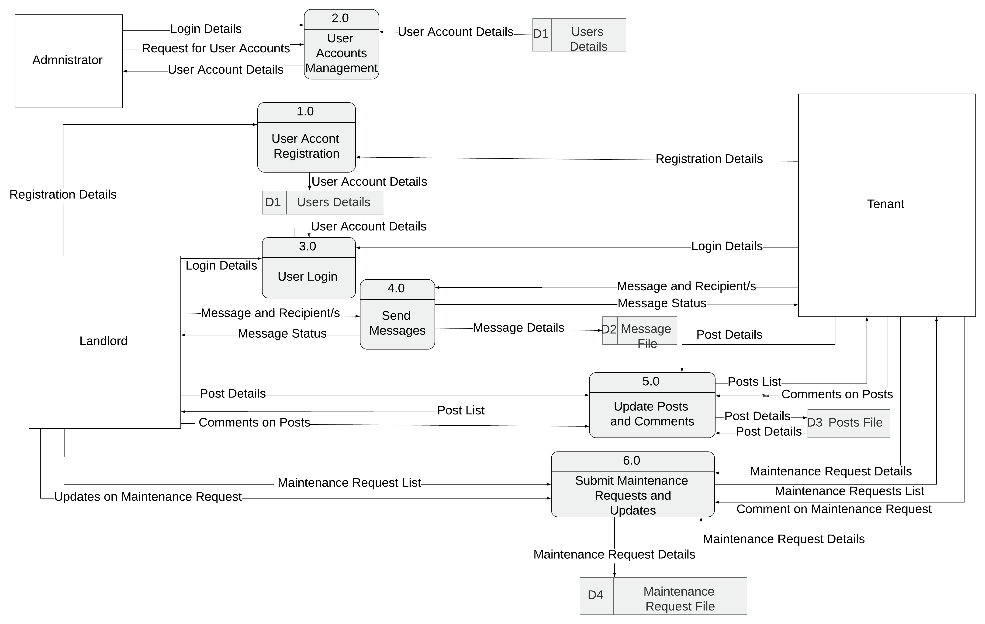

The level 0 diagram has six processes and four data stores. Data flows coming out of a data store indicate that information is retrieved from the data store. For example, process 2.0(User Accounts Management) retrieves user account details from the Users Details data store. Data flows going into a data store indicate that information is added to the data store. For example, process 1.0(User Account Registration) adds a new user account details to the User Details data store.

## 4.4 Entity Relationship Diagram

An entity relationship diagram (ERD) is a picture that shows the information that is created, stored, and used by a business system. An ERD can be read to discover the individual pieces of information in a system and how they are organized and related to each other (Dennis, Wixon, & Roth, 2012).

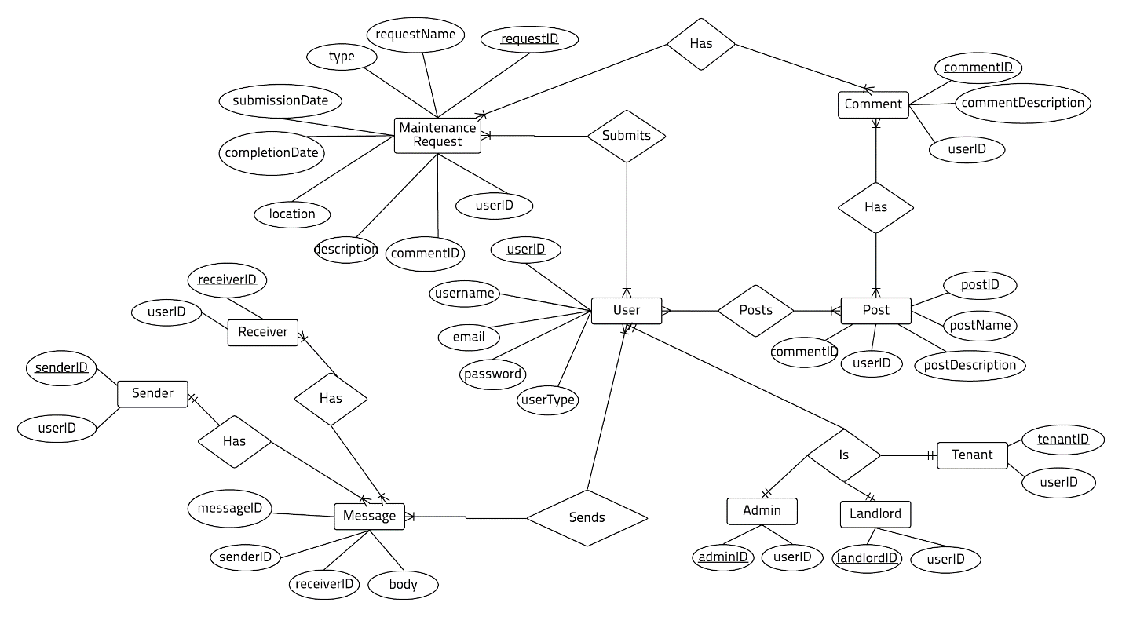

The ERD has various entities, attributes, relationships and cardinalities. There are various entities such as maintenance requests, posts and users. For example, the user entity has various attributes such as userID and can send or receive multiple messages. The user can be either an administrator, landlord or tenant depending on the userType and both maintenance requests and posts can have comments.

## 4.5 Database Schema

A database schema is the skeleton structure that represents the logical view of the entire database. A database schema defines its entities and the relationship among them. It defines how the data is organized and how the relations among them are associated. It formulates all the constraints that are to be applied on the data (Tutorialspoint, n.d.).

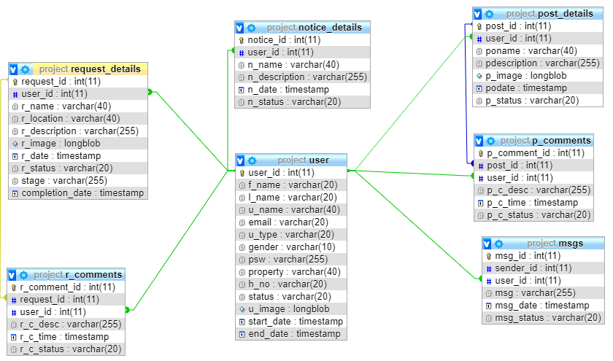

The database schema above contains a descriptive detail of the database that will save the details of the users,landlord and tenant, message details, post details and comments on each post, and maintenance request details and their respective comments. The schema defines the tables, relationships, types and indexes among others. It has tables such as a landlord table and a maintenance request table among others. The tables are also inclusive of primary and foreign keys.

## 4.6 User Interface Designs

The user interface design defines the way in which the users will interact with the system and the nature of the inputs and outputs that the system accepts and produces.

### 4.6.1 Login or Sign Up Page Wireframe

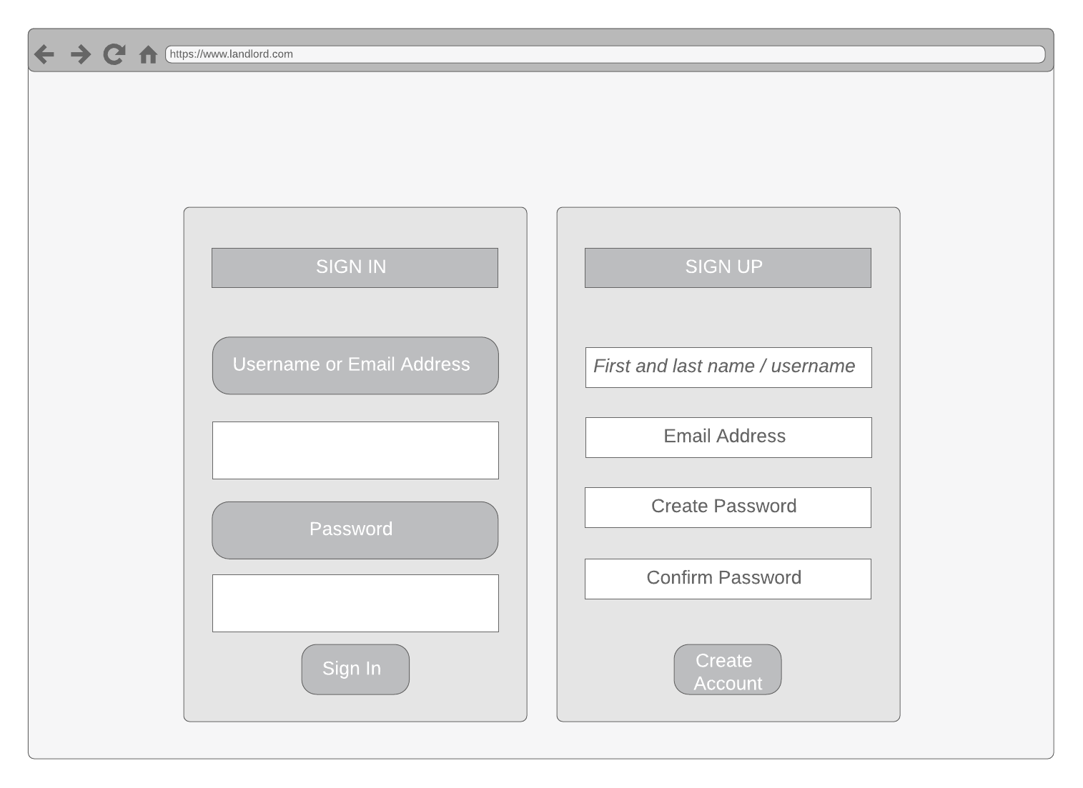

### 4.6.2 Account Details Page Wireframe

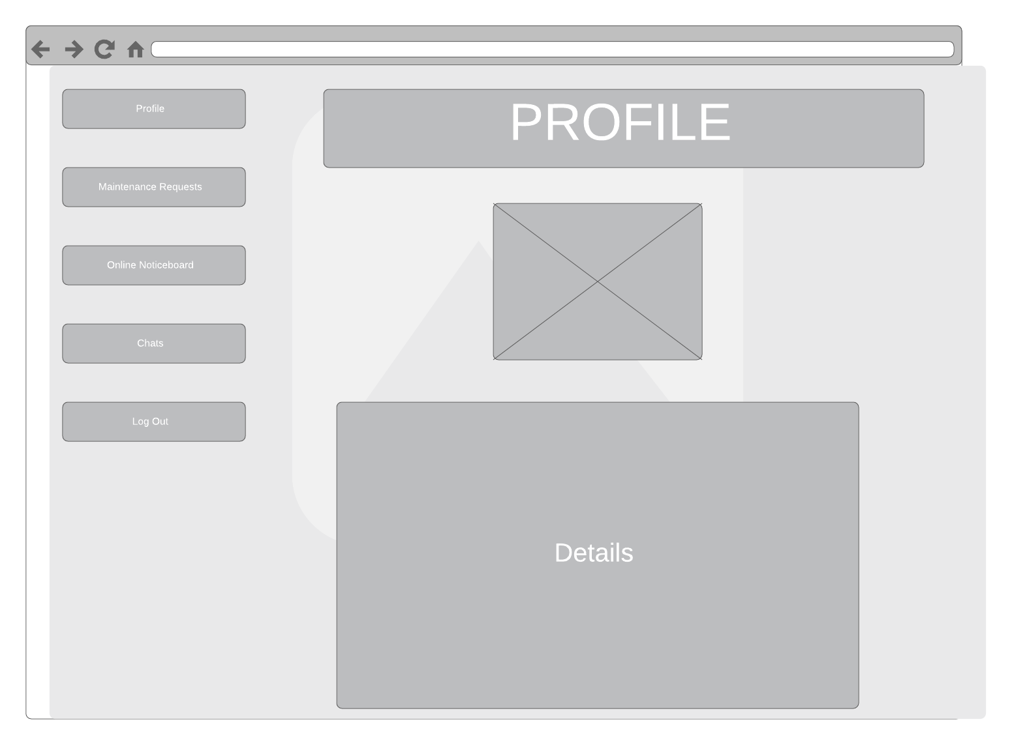

### 4.6.3 Maintenance Requests Page Wireframe

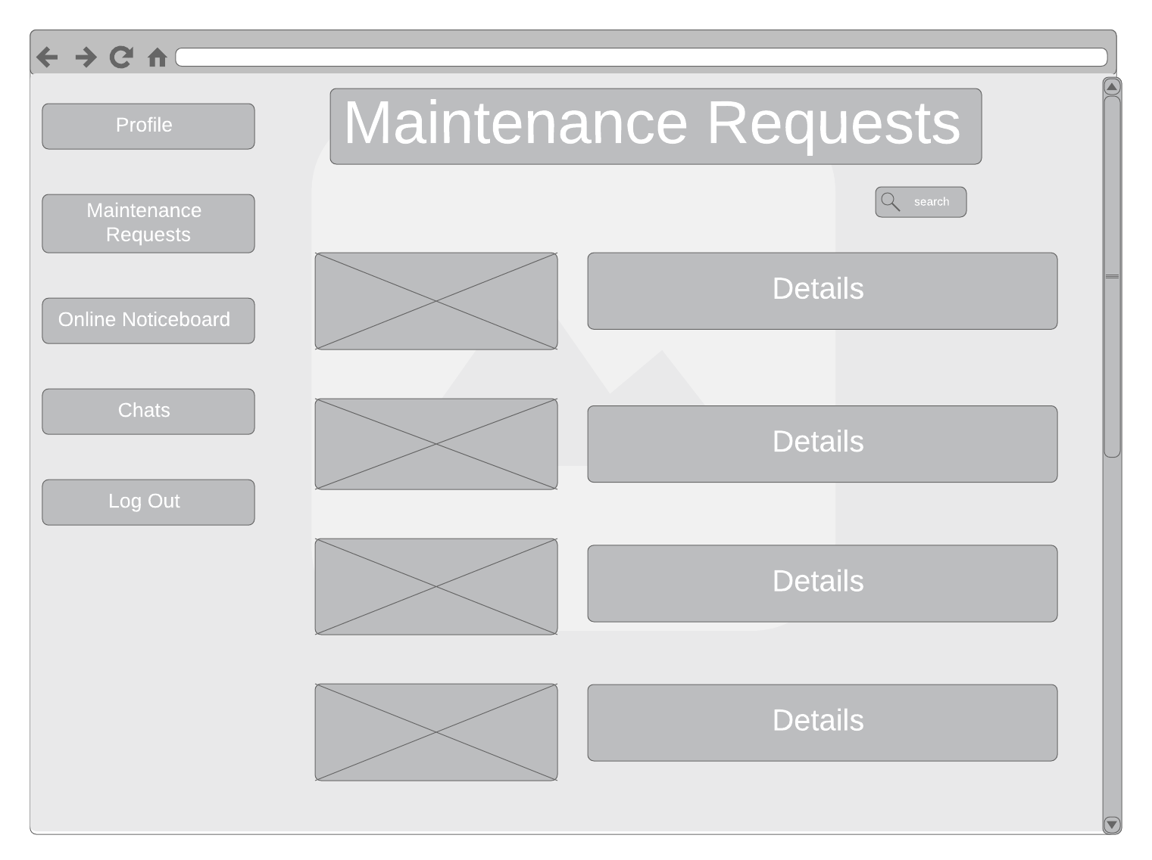

### 4.6.4Online Noticeboard Page Wireframe

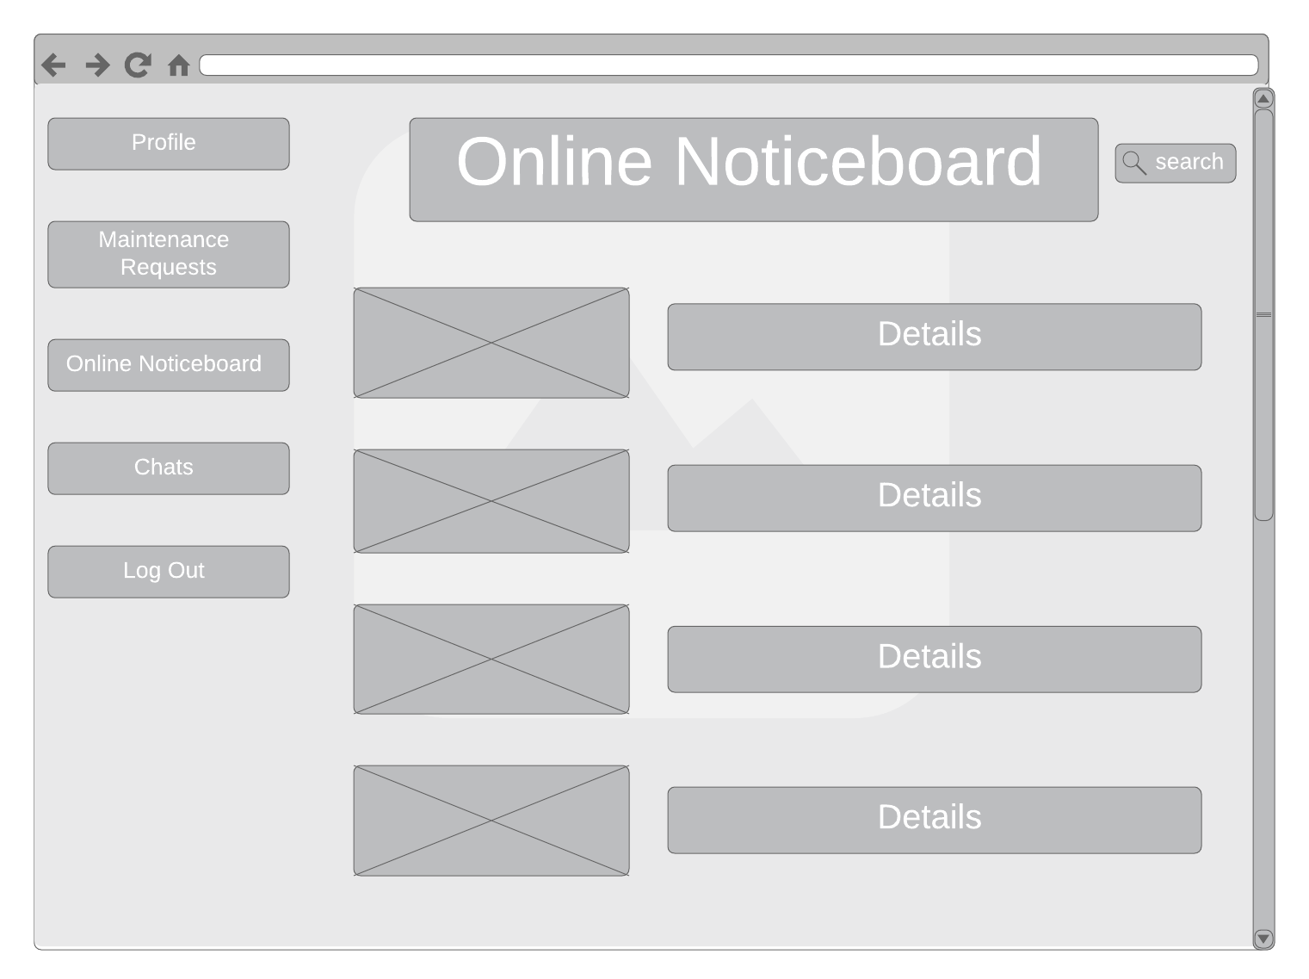

### 4.6.5 Chats Page Wireframe

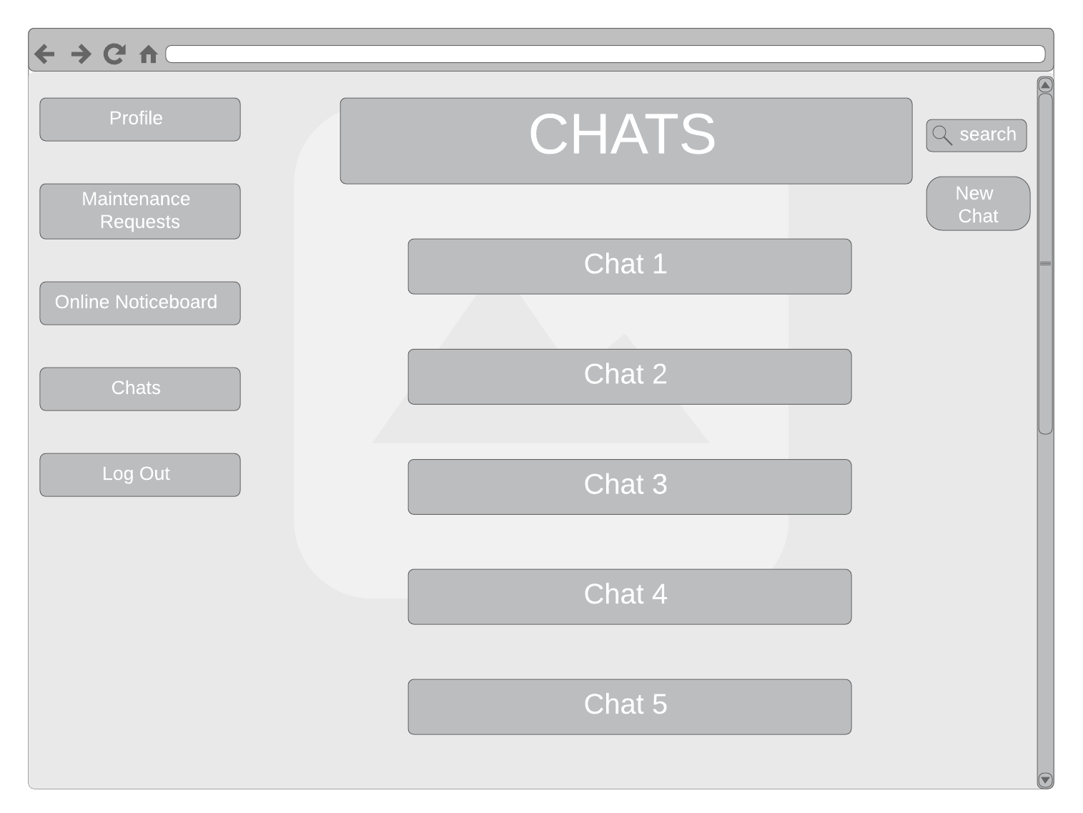

# Chapter 5: Implementation and Testing

## 5.1 Introduction

This chapter includes all modules that were implemented and how testing was done for both

functional and non-functional requirements.

## 5.2 Implementation

### 5.2.1 Landing Page

This page serves as the entry point for the web site. It includes a brief summary of the features offered by the system such as direct chats and a maintenance request module. It also includes a description a web based system and contact details. Lastly, it includes a link to the signup and login page.

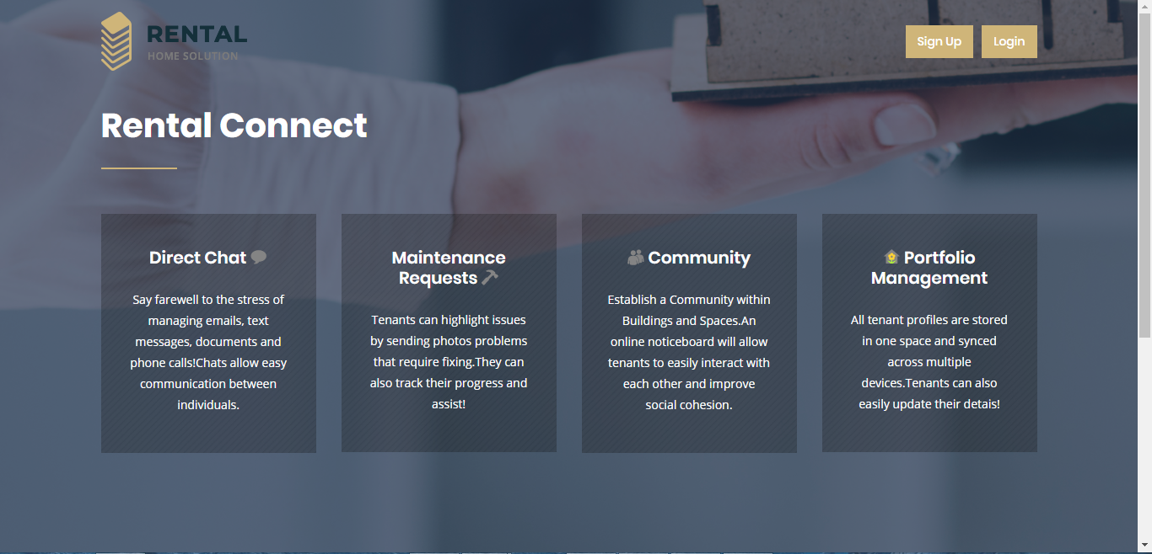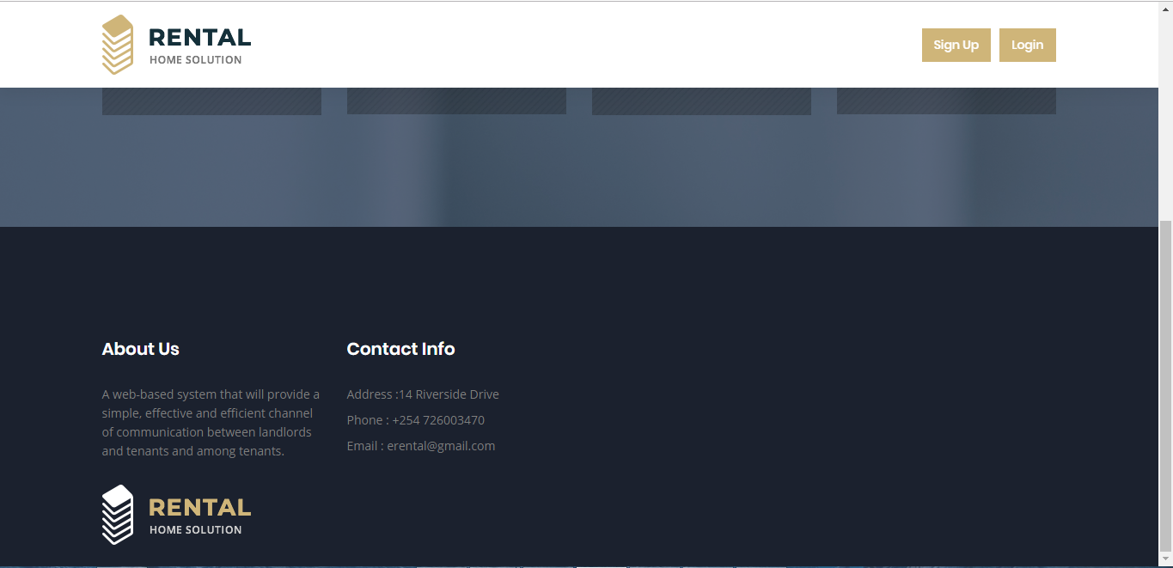

### 5.2.2 Sign Up

For a user to register successfully, they must fill in all the fields appropriately. The user must have a unique username and email as well as a password that is greater or equal to 8 characters. Each property can have only one landlord and an error is displayed if a user tries to register as a landlord for a property that already has a landlord. In addition, on clicking the tenant checkbox under user type, an input field for house number appears. Lastly, it allows a user to choose an image as their profile picture. Upon registration, the user is automatically logged into their account.

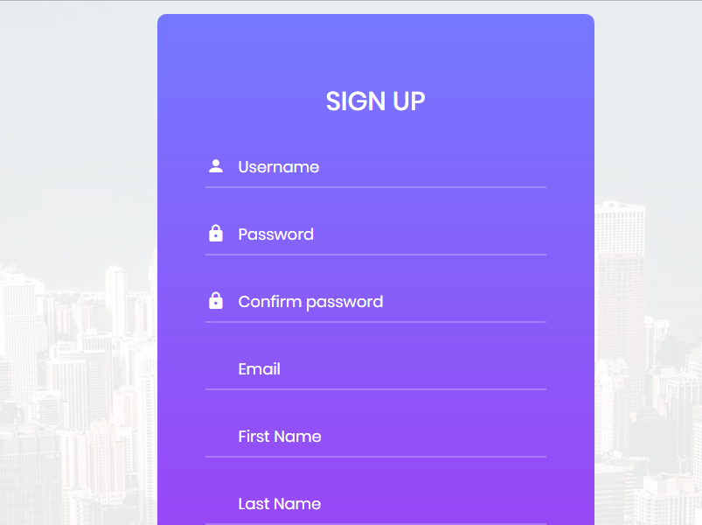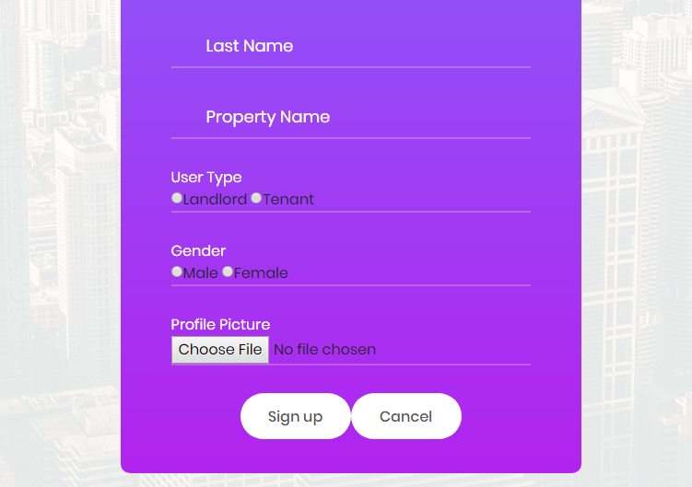

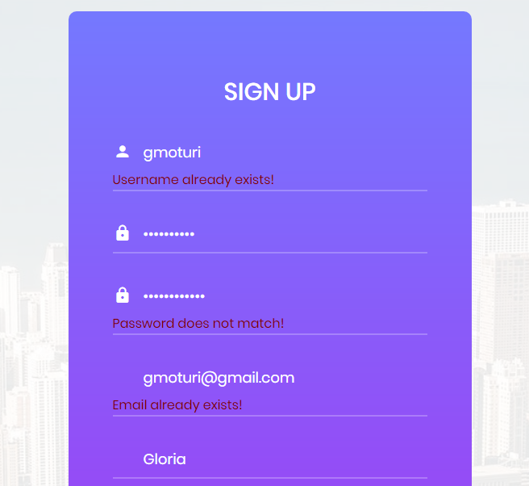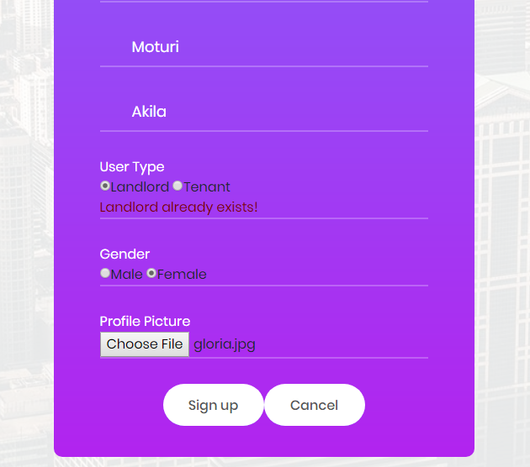

### 5.2.3 Login

For a user to successfully log in into the system, they must fill in their username and their password correctly to begin a session. If not they will be alerted that their details are incorrect.

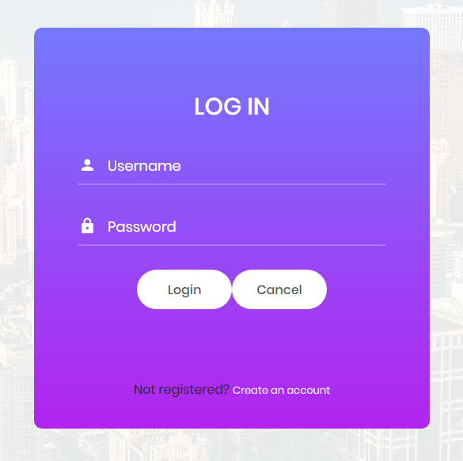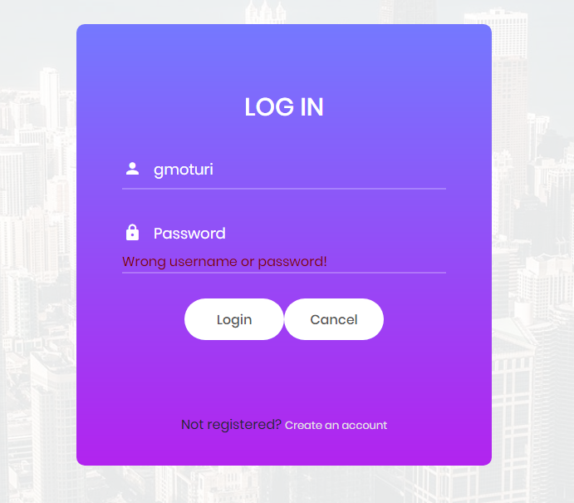

### 5.2.4 Home Page

### 5.2.5 Chats Module

#### 5.2.5.1 Contacts Page

The contacts page has a list of all the users for that specific property that a user can message. For each user it displays the username, full name and house number if the user is a tenant or the word landlord if the user is a landlord. The page allows a user to search for a specific user using any of the details above. The keyup event was binded on the input search so that on every keyup event a result is displayed.

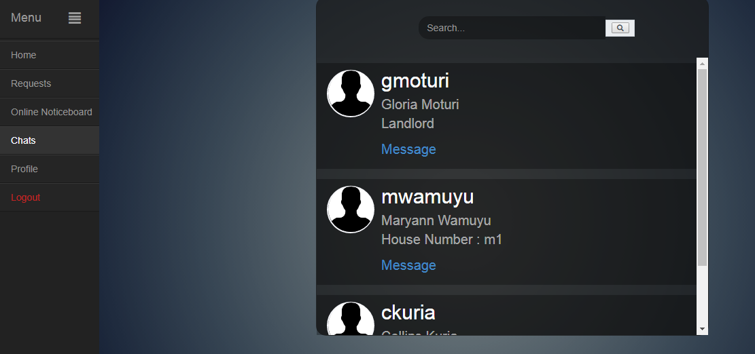

#### 5.2.5.2 Chat Box

The chat box displays all the messages between the user and another user. It uses a javascript function to automatically scroll down to the bottom of the chat box when the chat is opened or a new message is sent. In addition, it allows the user to delete the messages he or she sent and also allows a user to search for a particular message.

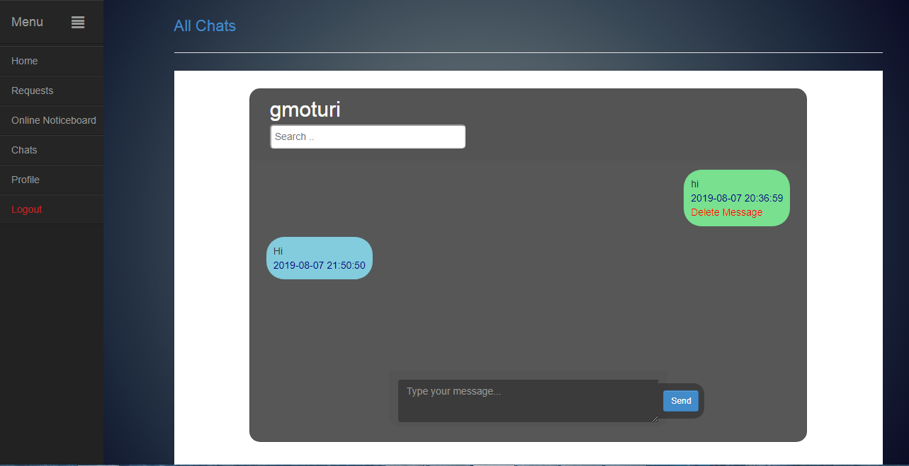

### 5.2.6 Maintenance Requests Module

### 5.2.7 Online Noticeboard Module

### 5.2.8 Profile Module

The profile page displays details such as the user image, username, email, first name, last name, property type, house number if the user is a tenant and gender. In addition, the profile module allows a user to update his or her personal details.

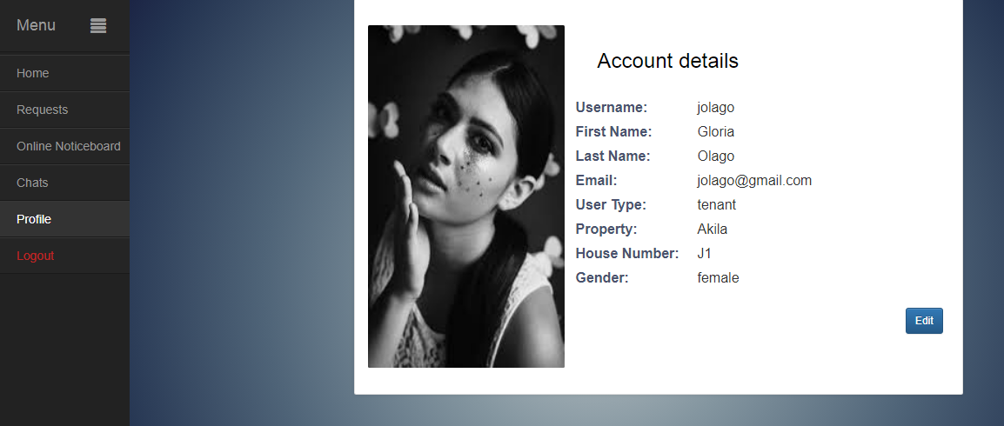

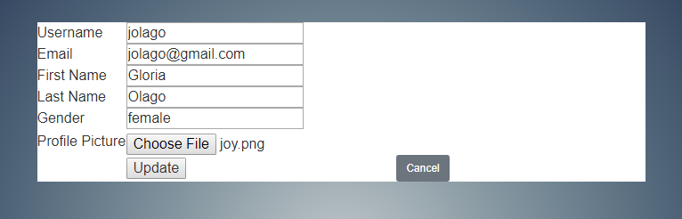

### 5.2.9 Reports Module

## 5.3Testing

# Chapter 6: Conclusions, Recommendations and Future Works

## 6.1 Introduction

This chapter discusses the conclusions, recommendations and future works that can be done on the system.

## 6.2 Conclusions

## 6.3 Recommendations

The system has been designed to be compatible with a wide range of web browsers and internet connection speeds, however it is strongly recommended to use a javascript enabled , modern web browser and a fast broadband internet connection for the most pleasing web site experience. Additionally, the users should have a basic understanding of English and how to access websites.

## 6.4 Future works

In the future, the system can be implemented in other languages to reach a multilingual customer base. Additionally, the system can be implemented as a mobile application. This will enable the system to offer basic content and functionality to users in offline mode and ease sending of notifications such as push and in-app notifications. Morever, mobile applications have the advantage of utilizing mobile device features like a camera and GPS. This would make submission of maintenance requests easier.

# References

*Communication*. (n.d.). Retrieved from Tell Us: https://www.tellusapp.com/communication/

Guide to Becoming a Successful Landlord. (2017, March 15). *Daily Nation*.

Hey Landlord Limited. (2019). Retrieved from HeyLandlord Web Site: https://heylandlord.co/

Kendall, K. E., & Kendall, J. E. (2011). *Systems Analysis and Design.* New Jersey: Pearson.

Onyango, O. (2018, September 11). Don’t be intimidated: How to deal with your rogue landlord. *Standard*.

Property Vista. (2018). *Landlord Tenant Communication*. Retrieved from Property Vista: https://www.propertyvista.com/en-us/features/communications/

*Rental Property*. (2019, May 29). Retrieved from BusinessDictionary: http://www.businessdictionary.com/definition/rental-property.html

Tellus. (2019). Retrieved from tellusapp: https://www.tellusapp.com/communication/

The Tenants Voice. (2019, May 29). *The Role of he Landlord*. Retrieved from The Tenants Voice: https://www.thetenantsvoice.co.uk/

Tutorials Point. (2016). Design Thinking.

# Appendix

Appendix A: Gantt Chart

